**LAB # 04**

**LAB TASK**

**Q No. 1:** The following program shows the two methods of 2D array initialization and is implemented in java. You are required to implement in C++?

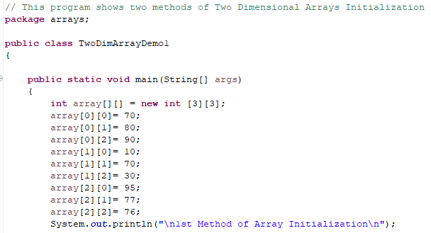

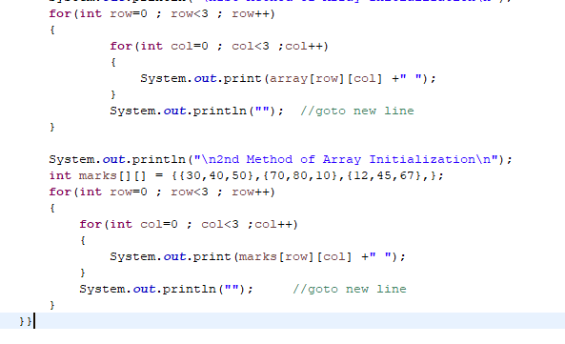

Output should be like that:

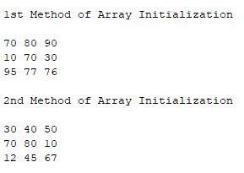

**Q No. 2:** The following program will take values from user for two-dimensional array and display the values is implemented in java. You are required to implement in C++?

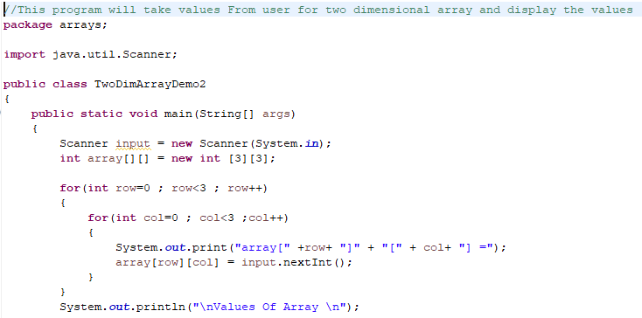

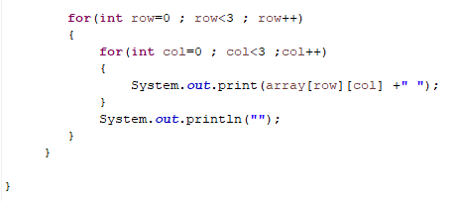

Output should be like that:

